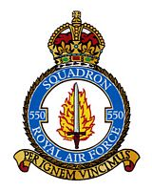

550 SQUADRON AND RAF NORTH KILLINGHOLME ASSOCIATION

**550 SQUADRON HISTORY**



We are pleased to announce that “Five Fifty”, the 266 page official illustrated history of 550 Squadron written by Patrick Otter, has now been published.

The book comprises 266 pages and nearly 100 photographs.

It is priced at £10 each if you collect in North Killingholme at the forthcoming Reunion, or £15 per single copy for those that are posted within the UK.  
*The cost of postal charge for multiple copies or to countries outside the UK is available on request.*

Please indicate below if you would like to reserve a copy.

**Please do NOT send payment with this Form**

Name of member :

Number of copies required:

A. Will you collect in person during the North Killingholme reunion? YES / NO (please indicate)

B. If to be posted, please give your contact details:

Telephone Number : Email:

**PLEASE RETURN FORM TO:** [**mailto:mikeleeman@btinternet.com?subject=550%20Squadron%20History**](mailto:mikeleeman@btinternet.com?subject=550%20Squadron%20History)

Allow up to 28 days for delivery