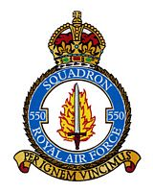
`

550 SQUADRON AND RAF NORTH KILLINGHOLME ASSOCIATION REUNION
Friday 7th and Saturday 8th July 2023

BOOKING FORM
Name of Member:
Accompanied By:
Home Address:

Telephone No: Email:
Special Requirements (eg wheelchair etc) :
Accommodation at the Ashbourne Hotel
Members and friends must reserve rooms directly with the hotel and pay their own accounts on departure. You are advised to mention “550 Squadron Reunion” when making your booking. The Association will not be booking any individual rooms, but we would like to know the names of those who are staying.

Friday 7th July:

Saturday 8th July:

Church and Afternoon Tea & Cakes. Number of places:

Associated Events – Sunday 9th July
Tour of North Killingholme Airfield by car - led by George Turner Number of places:
This is an informal tour that George is happy to lead if there is sufficient interest

Annual Subscription
Annual Subscription for year beginning 1st July 2023 will remain at £5.50 per person. Payments by bank transfer are preferred and the association’s bank details are as follows:

Sort Code : 30 - 93 - 72 Account Number : 01206018 Please reference any payments with your name.

If you have not already made bank arrangements, you are invited to pay now by cheque

Number of members ___________ @£5.50 per head: £
Names of members being paid for

TOTAL PAYMENT : £

Cheques should be made out to “550 Squadron Association” and returned with this completed booking form NO LATER THAN FRIDAY 23rd JUNE to:

Liz Broddley, 15 St Crispins Close, North Killingholme, North Lincs, DN40 3JN
Telephone: 01469 540628 Email: lbroddley@gmail.com
Meal Requirements
The menus for Friday and Saturday nights are shown overleaf. Please indicate below your choices. Members must pay the hotel directly for all meals taken.

Friday 7th July 8.00pm. Relaxed, informal evening . No seating plan.

2 courses £20 per person (Starter & Main - or - Main & Dessert)
3 courses £24per person ( Starter, Main & Dessert)

STARTERS:
 | Name | Name | Name | Name
Homemade Leek & Potato Soup
Seasonal Melon
Terrine of Ham Hock
Smoked Salmon & Prawn Cocktail

MAIN COURSES:
Roasted Chicken Breast
Traditional Beer Battered Haddock
Root Vegetable & Cheddar Tart

DESSERTS:
Dark Chocolate Brownie
Chilled Rice Pudding
Warm Treacle Tart

Please advise below if you have any special dietary requirements:
Saturday 8th July 7.30pm. Formal Dinner with seating plan.
3 courses £32.00 per person ( Starter, Main & Dessert)

Seating Preference: Please let us know if you would like to sit with anyone in particular:
STARTERS:
 | Name | Name | Name | Name
Roasted Tomato Soup
Chicken Liver Pate
Warm Smoked Poacher Torte
MAIN COURSES:
Roast Sirloin of Beef (Cooked Pink or Well Done)
Roast Pork Loin
Baked Haddock
Goats Cheese Cheesecake

Raspberry Meringue Roulade
Vanilla Bean Panna cotta
White Chocolate Cheesecake

Saturday 8th July 2023
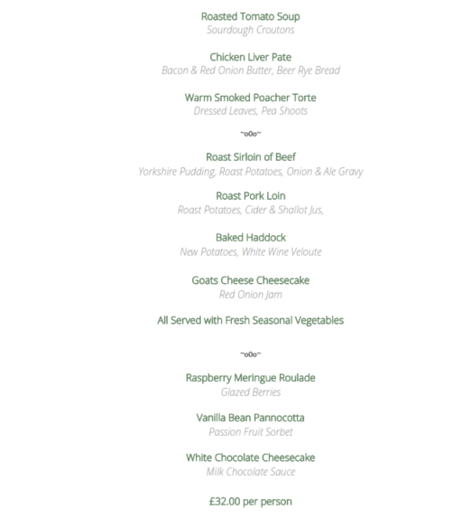

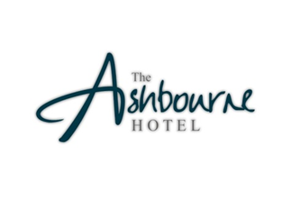
Friday 7th July 2023
