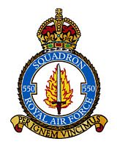`

550 SQUADRON ASSOCIATION REUNION

Friday 11th and Saturday 12th July 2025

**BOOKING FORM**

Name of Member:

Accompanied By:

Home Address:

Telephone No Email:

Special Requirements (eg wheelchair etc) :

**Accommodation at the Ashbourne Hotel**

Members and friends must reserve rooms directly with the hotel and pay their own accounts on departure. The Association will not be booking any individual rooms, but we would like to know the names of those who are staying.

Friday 11th July:

Saturday 12th July:

Church and Afternoon Tea & Cakes. Number of places:

A**ssociated Events – Sunday 13th July**

Tour of North Killingholme Airfield by car - led by George Turner Number of places:

*This is an informal tour that George is happy to lead if there is sufficient interest*

**Annual Subscription**

Annual Subscription for year beginning 1st July 2025 will remain at £5.50 per person. Payments by bank transfer are preferred and the association’s bank details are as follows:

Sort Code : 30 - 93 - 72 Account Number : 01206018 Please reference any payments with your name.

If you have not already made bank arrangements, you are invited to pay now by cheque

Number of members ___________ @£5.50 per head: £

Names of members being paid for

**TOTAL PAYMENT : £**

Cheques should be made out to “550 Squadron Association” and returned with this completed booking form **NO LATER THAN FRIDAY 20th JUNE** to:

Liz Broddley, 15 St Crispins Close, North Killingholme, North Lincs, DN40 3JN

Telephone: 01469 540628 Email: lbroddley@gmail.com

**Meal Requirements**

The menus for Friday and Saturday nights are shown below. Please indicate below your choices. **Members must pay the hotel directly for all meals taken.**

**Please advise below if you have any special dietary requirements:**

**Friday 11th July 7.30pm**. Relaxed, informal evening . No seating plan.

2 courses £24 per person (Starter & Main - or - Main & Dessert)

3 courses £29 per person ( Starter, Main & Dessert)

**STARTERS:**

|  |  |  |  |  |
| --- | --- | --- | --- | --- |
|  | Name | Name | Name | Name |
| Leek & Potato Soup |  |  |  |  |
| Deep Fried Brie |  |  |  |  |
| Beef Fritter |  |  |  |  |
| Chicken Liver Parfait |  |  |  |  |

**MAIN COURSES:**

|  |  |  |  |  |
| --- | --- | --- | --- | --- |
| Battered or Grilled Haddock |  |  |  |  |
| Gammon Steak |  |  |  |  |
| Beef & Ale Pie |  |  |  |  |
| Tomato, Basil & Halloumi Risotto |  |  |  |  |

**DESSERTS:**

|  |  |  |  |  |
| --- | --- | --- | --- | --- |
| Treacle Sponge |  |  |  |  |
| Duo of Chocolate |  |  |  |  |
| Lemon Meringue Roulade |  |  |  |  |

**Saturday 13th July 7.30pm**. Formal Dinner with seating plan.

3 courses £34.00 per person ( Starter, Main & Dessert)

**Seating Preference**: Please let me know if you would like to sit with anyone in particular:

**STARTERS:**

|  |  |  |  |  |
| --- | --- | --- | --- | --- |
|  | Name | Name | Name | Name |
| Vegetable Soup |  |  |  |  |
| Cheese & Onion Quiche |  |  |  |  |
| Chicken & Mushroom Terrine |  |  |  |  |

**MAIN COURSES:**

|  |  |  |  |  |
| --- | --- | --- | --- | --- |
| Roast Rib of Beef |  |  |  |  |
| Roast Haddock |  |  |  |  |
| Roast Loin of Pork |  |  |  |  |
| Tomato, Basil & Halloumi Risotto |  |  |  |  |

|  |  |  |  |  |
| --- | --- | --- | --- | --- |
| Apple Pie |  |  |  |  |
| Ice Cream Terrine |  |  |  |  |
| White Chocolate Cheesecake |  |  |  |  |

**Saturday 12th July 2025**

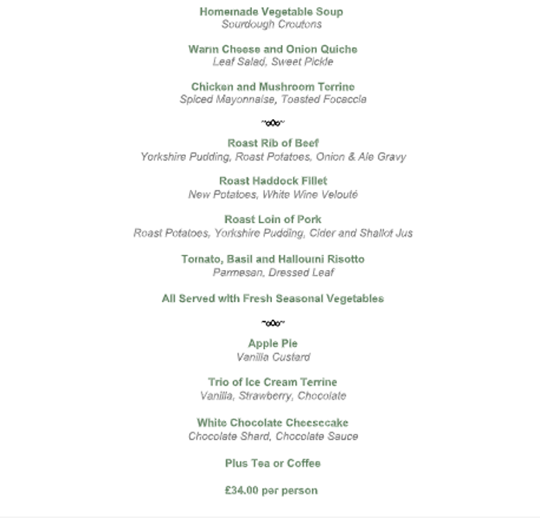

**Friday 11th July 2025**

